Patient Education Package: WARNING SIGNS IN CHILDREN WITH CANCER
This patient education package was developed to support health care providers caring for children and families coping with a childhood cancer diagnosis. This package includes collated resources that can be used to educate children and families on the serious side effects that can occur from cancer and cancer treatment. It is imperative that families are familiar with recognizing and reacting appropriately to these side effects to decrease the possibility of severe complications or even death.
This document is intended to: provide easy access to high quality, evidence based resources (brochures, videos, testimonials etc.) that can be used according to the individual learning needs of children and families. Suggestions on how to customize education and how to effectively use educational materials with children and families can be found below.

How to Effectively Use This Patient Education Package

- Assess
- The recipient(s) of health education
- Circumstances around education

- Customize Health Information
- Choose resources and strategies that will be most
effective for the health education

- Evaluate Effectiveness
- Was the education effective?
- Did the recipient understand the key messages?
- Did the recipient retain what was taught?

RESOURCES FOR PATIENTS & FAMILIES:
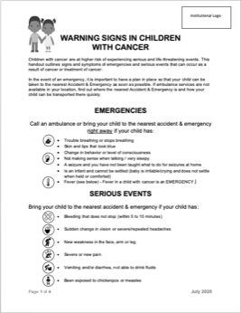
- Warning Signs for Children with Cancer Handout

Outlines signs and symptoms of emergencies and serious events that can occur as a result of cancer or treatment of cancer. Double click on the icon below (↓) to access and edit the Warning Signs Handout.docx document:
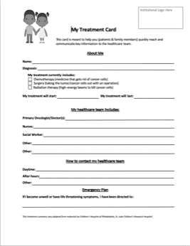
- Patient Treatment Card

Helps patients and family members quickly reach and communicate key information to the healthcare team. Double click on the icon below (↓) to access and edit the Warning Signs Handout.docx document:
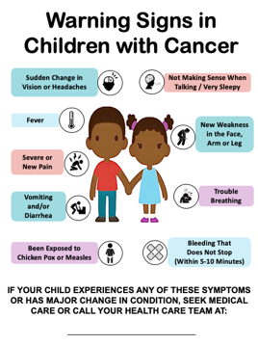
- Warning Signs for Children with Cancer Poster
Outlines signs and symptoms of emergencies and serious events that can occur as a result of cancer or treatment of cancer. This can be posted in the clinic to communicate to patients and family members when and how to seek medical care. Right click on the icon below (↓) and select Presentation Object > Edit to access and edit the Warning Signs Handout.docx document:
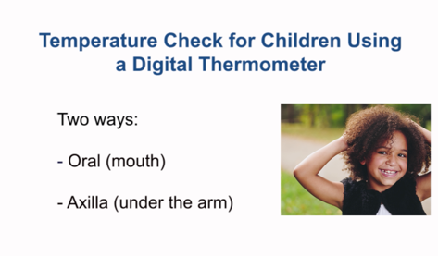
- Instructional Video: How to take a temperature in children with cancer
This video for patients and families shares two ways (oral and axilla) to take temperature using a digital thermometer.

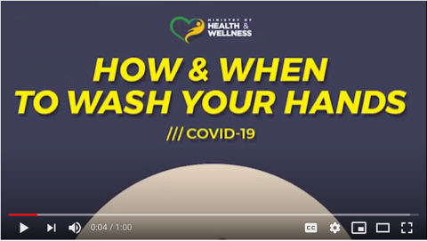
- Instructional Video: Handwashing
This video “How to Wash your hands” by the Ministry of Health, Jamaica (March 14, 2020) shares proper handwashing technique.

RESOURCES FOR HEALTH CARE PROVIDERS:
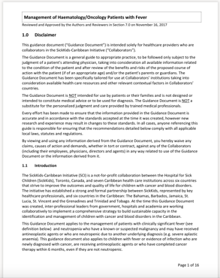
SickKids-Caribbean Initiative (SCI) Guide: Management of Haematology/Oncology Patients with Fever
Double click on the icon below (↓) to access the SCI Management of Fever.pdf document:

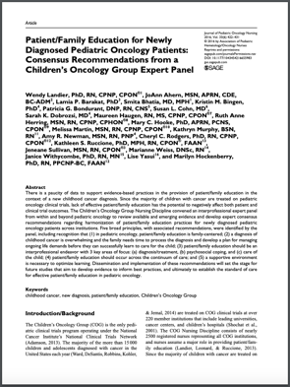
Article outlining recommended principles to use when providing education to new patients/families

Landier et. al. (2016). Patient/Family education for newly diagnosed pediatric oncology patients: Consensus recommendations from a children’s oncology group expert panel. Journal of Pediatric Oncology Nursing, 33(6), 422-431.

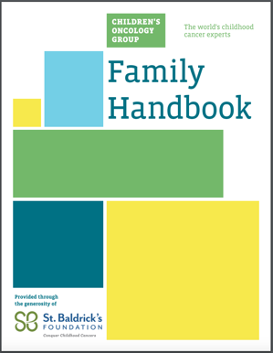
Children's Oncology Group (COG) Patient & Family Education Materials
This website provides links to the following resources:
- Family Handbook
- New Diagnosis Guide
- Includes information on emergencies, fevers, managing symptoms and preventing infection
- New Diagnosis Guide Slide Set
- Power-Point presentation that can be downloaded, printed or used electronically to support education done with children and families

Best Practices for Effective Use of Patient Education Materials

Patient education materials should always be used as a tool to support a comprehensive patient education strategy, and not in isolation.
- Assess using PEEK:
Physical, Emotional, Experiential, Knowledge Readiness¹

Physical:
- The best possible circumstances for doing teaching
- Timing – low stress, dedicated time when you will not be interrupted, avoid just before discharge
- Environment – quiet, private, familiar area
Emotional:
- Developmental level
- Frame of mind
- You could ask the recipient:
  - How do you feel about …….?
  - Are there any issues that might impact your learning right now?
  - What is on your mind right now regarding…..?
Knowledge:
- Present knowledge base/previous learning
- Cognitive ability and learning disabilities
- Literacy
- Health literacy
  - Ability to understand, process and use health information (verbal, written, visual etc.) in order to make informed decisions specific to one’s health
  - Influenced by many factors, such as culture/language and knowledge of health topics & health care systems²

- Customize Education

- Choose strategies & resources that will be most effective for the individual based on above assessment
- Personalize whatever patient education material/resource you are using by adding the patient's name, medicines, and/or specific care instructions.

Strategies
- Circle or highlight the most important points as you talk about them.
- Use materials that are colourful and interesting whenever possible
- Review material with the recipient more than once. New learning requires repetition for comprehension. This can take place with different team members within clinic or inpatient visits
- Use multiple strategies for teaching in order to meet the needs of different learning styles.
- When literacy level is low, consider strategies such as recording the discussion or reading the pamphlet
- Use plain language. Key elements of plain language include:
  - Order information form most important to least important
  - Break down information into simple, manageable sections
  - Use plain language as much as possible and explain any medical terminology
  - Clarify any misunderstandings before moving on. If there is a misunderstanding, try to explain it in a different way
    - E.g. Saying “health problem” instead of “condition” (more examples at the end of the document)
- Document a brief summary of teaching provided, so you and other team members are aware of content that was previously reviewed, prior to the next hospital visit
- All patient education materials being used with patients and families should be reviewed on a regular basis to ensure they are up to date and reflect current practice

- Evaluate Effectiveness

- Checking for comprehension can lead to better health outcomes.

- Use teach-back method to confirm understanding. Ask the recipient to explain back to you– in their own everyday words. You could ask the recipient:
- “Just to be sure I've explained this well… can you describe what I’ve said, as you would to a friend?”
- “Can you show me how you will do this yourself (i.e. administer medication) when you leave here, so I’ll know if I’ve explained it clearly?”
- Use open-ended questions to assess understanding. You could ask the recipient:
  - What things will you be looking out for?
  - When will you need to call us, or come in?
  - Is there anything I did not explain well? Anything I missed that you wanted or expected to hear and learn about?
  - Do you have any questions? Avoid questions like “Did you understand that?”
- White, K.M., & Dudley-Brown, S. (2012). Translation of evidence into nursing and health care practice. New York, NY: Springer Publishing Company.
- U.S. Department of Health & Human Services. (2008, July 24). Health literacy basics. In Quick guide to health literacy. Retrieved from https://health.gov/communication/literacy/quickguide/Quickguide.pdf
Plain Language Examples
 | Problem Word: | Consider Using:
Medical Words  Frequently used by clinicians in healthcare | Condition  Dysfunction  Oral  Procedure  Sign  Symptom  Benign Growth /Tumor | Health problem/concern, how you feel  Problem  By mouth  Something done to treat/investigate your problem  Changes you see  What is not feeling right  Not cancer
Concept Words  Words used to describe an idea, metaphor or notion. | Adverse  Cognitive  Hazardous  Generic  Support | Bad  Learning, Thinking  Not safe; dangerous  Product without a brand name  Help with your needs
Category Words  Words that describe a group or sub-set | Avoid  Intake  Option  Referral  Wellness | Stay away from  What goes into your body (eat or drink)  Choice  See another doctor, second opinion  Good health
Value Judgement Words  Words that may need an example or visual to convey their meaning. | Adequate  Cautiously  Moderately  Routinely  Temporary | Enough  With care; slowly  Not too much  At the same time every day/week/month  For a little while

References
BC Cancer Agency. (2017, January). Fever and neutropenia. Symptom management. http://www.bccancer.bc.ca/health-professionals/clinical-resources/nursing/symptom-management

Centers for Disease Control and Prevention. (2018, November 5). Educational materials. Preventing infections in cancer patients. https://www.cdc.gov/cancer/preventinfections/educational-materials.htm

Children’s Hospital of Philadelphia. (2018). Oncology Family Handbook. Retrieved from https://media.chop.edu/data/files/pdfs/pfe/pfe-oncology-family-handbook.pdf

Children’s Oncology Group (COG). (2011). Family handbook (2nd ed.). Patients and families. https://childrensoncologygroup.org/downloads/ENGLISH_Handbook_2nd-Screen_Viewing.pdf

Children's Oncology Group (COG). (n.d.) Children’s oncology group family handbook. Patients and families. Retrieved from https://childrensoncologygroup.org/index.php/cog-family-handbook

Food Safety World Health Organization. (n.d.). Five keys to safer food. Retrieved from https://www.who.int/foodsafety/publications/consumer/en/5keys_en.pdf?ua=1

Grey Bruce Health Network. (2009, July). Febrile Neutropenia Patient Information Sheet. Retrieved from http://www.gbhn.ca/ebc/documents/FNPatientInformationSheetFeb2010_000.pdf

Lehrnbecher, T., Phillips, R., Alexander, S., Alvaro, F., Carlesse, F., Fisher, B….Sung, L. (2012). Guideline for the management of fever and neutropenia in children with cancer and/or undergoing hematopoietic stem-cell transplantation. Journal of Clinical Oncology, 30 (35), 4427-4437. Retrieved from https://www.ncbi.nlm.nih.gov/pubmed/22987086

Segel, G.B. & Halteman, J.S. (2008, January). Neutropenia in pediatric practice. Pediatrics in Review, 29(1), 12-24. https://doi.org/10.1542/pir.29-1-12 SickKids staff. (2011, June 9). Fever & neutropenia. About kids health. https://www.aboutkidshealth.ca/Article?contentid=863&language=English

St. Jude Children’s Research Hospital. (n.d.). Do you know…Blood counts. Blood products and blood counts educational materials. https://www.stjude.org/treatment/patient-resources/caregiver-resources/patient-family-education-sheets/blood-products-blood-counts/blood-counts.html

St. Jude Children’s Research Hospital. (n.d.). Do you know…How to take a temperature? Prevent and control infection educational materials. https://www.stjude.org/treatment/patient-resources/caregiver-resources/patient-family-education-sheets/prevent-control-infection/how-to-take-a-temperature.html

St. Jude Children’s Research Hospital. (n.d.). Do you know…Who to call? When to phone? Patient and family educational materials. https://www.stjude.org/treatment/patient-resources/caregiver-resources/patient-family-education-sheets/general-information/who-to-call-when-to-phone.html

The American Cancer Society medical and editorial content team. (2017, February 10). Watching for infection. Infections in people with cancer. https://www.cancer.org/treatment/treatments-and-side-effects/physical-side-effects/infections/watching-for-infection.html

This education package is intended for clinicians to consider using based on assessment of fit with your organization’s policies, procedures and specific context.
The education package is reflective of best practice at the time of sending and should be assessed at regular intervals to ensure it contuse to reflect current best practice with regards to management of serious side effects related to paediatric cancer and its treatment.

